Distractor
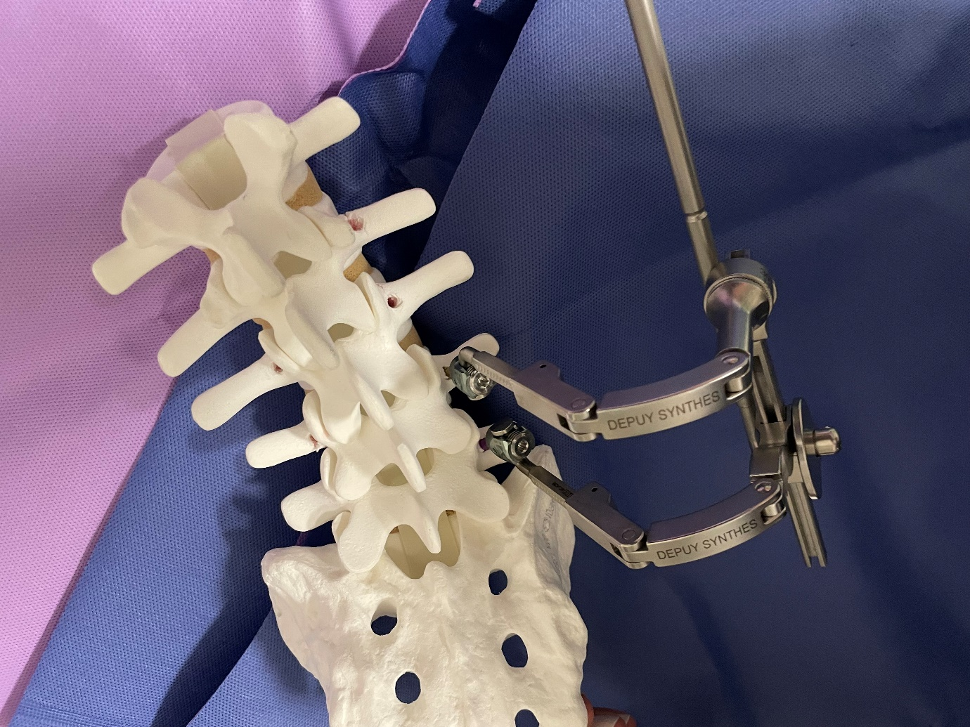
Needs to be moddled accurately, I have some more reference images, Spine does not need to be created just the tool.
Price for just the model and one for it rigged, nulls to control each part.

Robotic arm and environment.
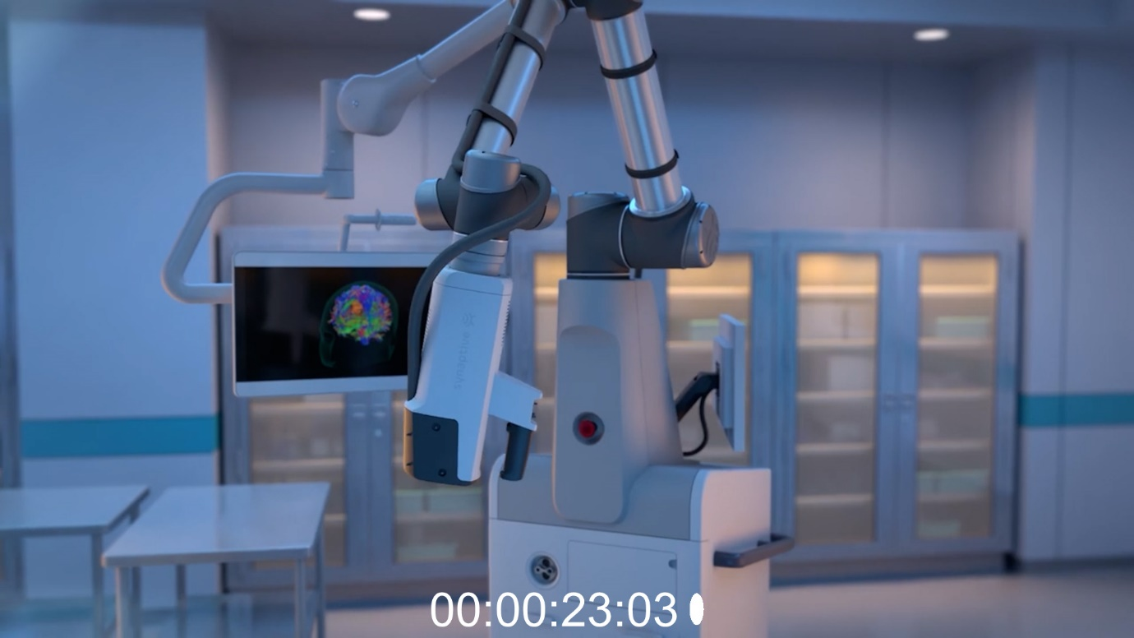
Will need the robotic arm created, must be accurate, I will forward some better reference.
I want a price on creating the arm with and without a rig for animation.
The room, pretty much as you see it but there will be some extra monitors, only one monitor would need to be created.
All models will need to be UVd and ready for texturing. Feel free to quote on texturing as well.

Pin
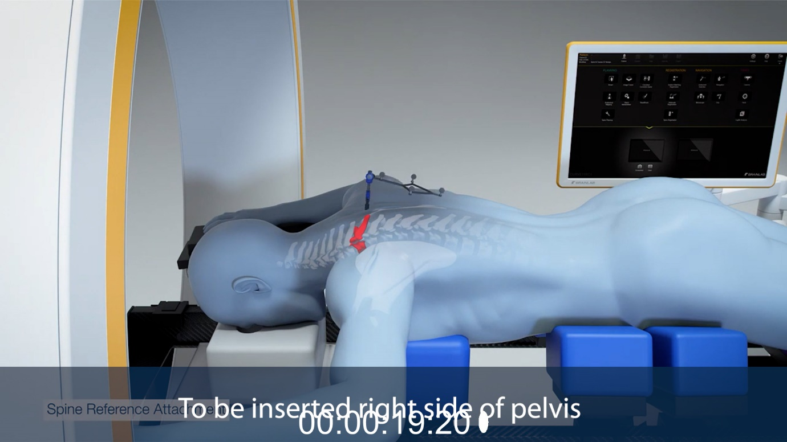
This pin, sorry hard to see but the thing sticking out of his back, not much to it and can get better reference.

BodyTom machine
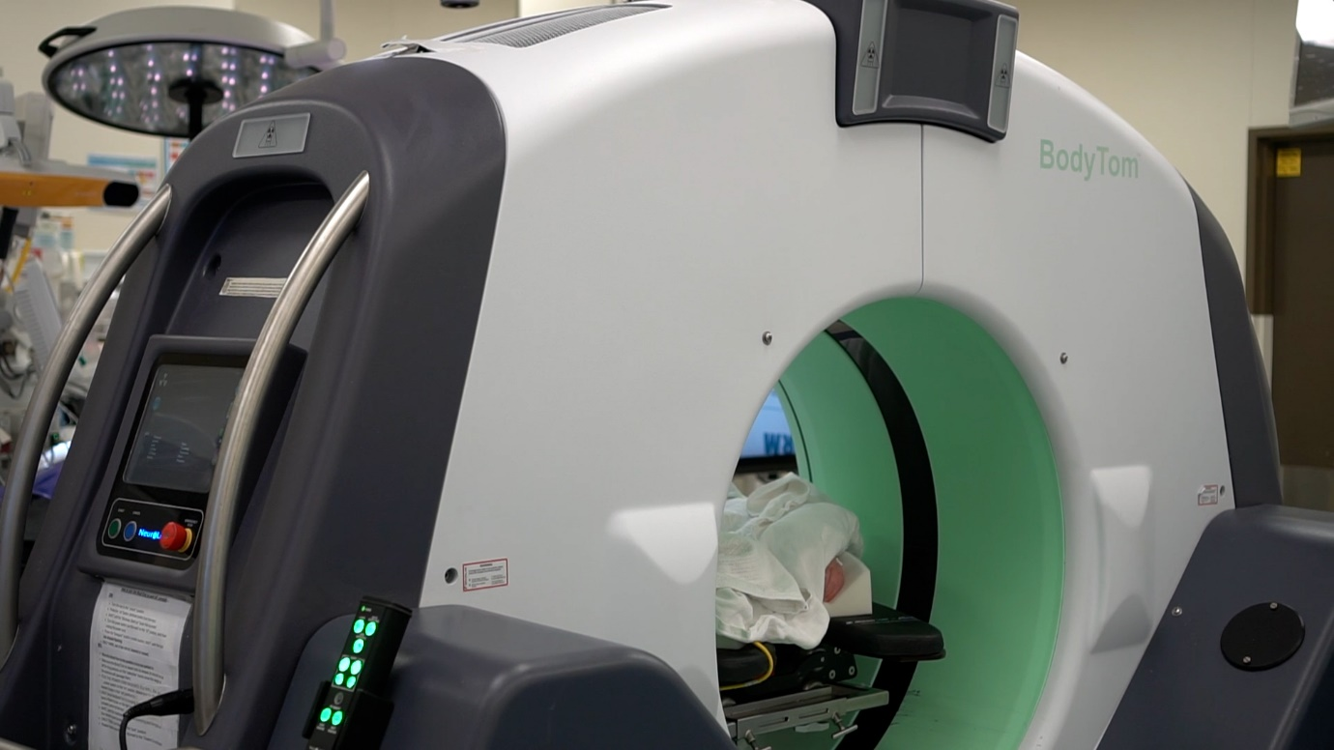
This will need to be modelled accurately as it is one of the main parts of the animation, again can get more reference. UVd and ready for texturing.

Muscle spreader
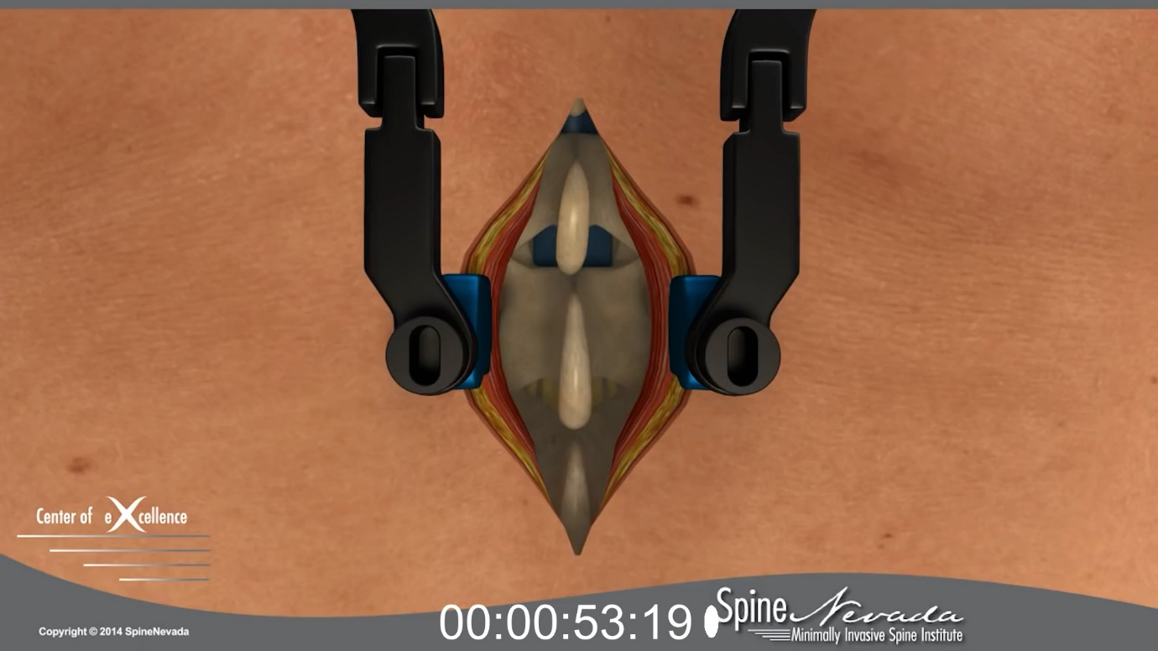
Device spreading the skin open, I need to get more reference from client but should be a similar model to create as the distractor (First image)

Screws
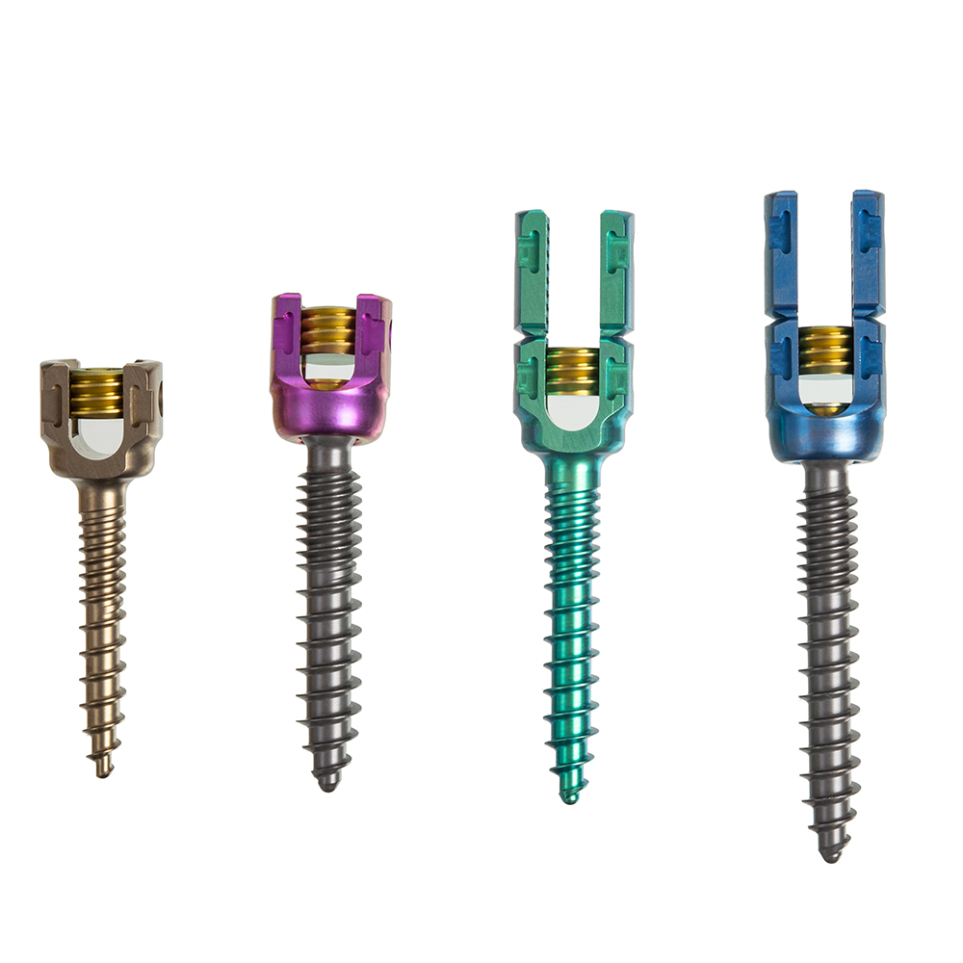
Need to check with client but I think we would only need to create one screw, but this is a sample of the type.

Drill
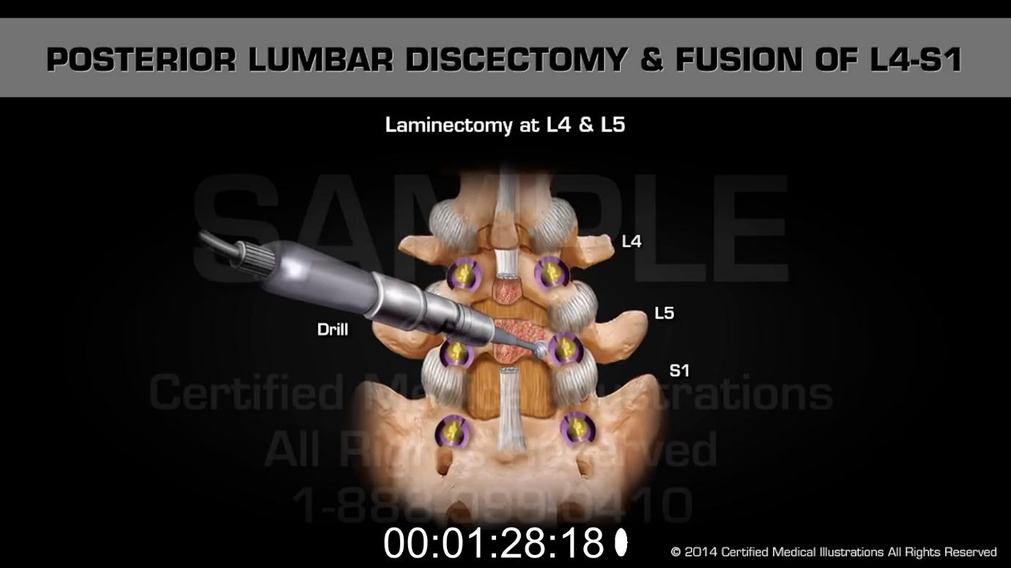
Again waiting for more info from client, but just the drill object needs to be created.

